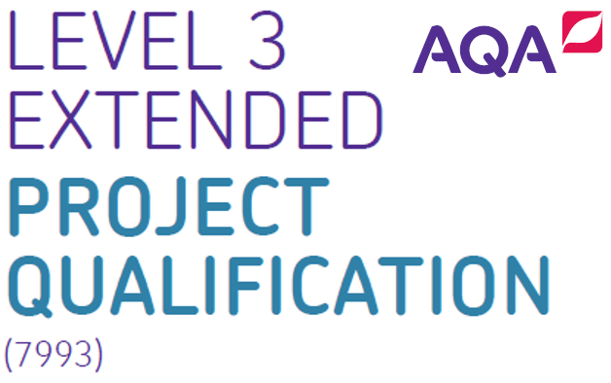

**EPQ Transition Booklet**

**Subject:** Extended Project Qualification

**Teachers:** BCH

Student Name and Surname: ________________________________

**[](http://www.google.co.uk/url?sa=i&source=images&cd=&cad=rja&docid=jcI3j4LoNpcPMM&tbnid=nmxuE4jUb6AWCM&ved=0CAgQjRw&url=http://www.cmpa-acpm.ca/cmpapd04/docs/ela/goodpracticesguide/pages/professionalism/Being_respectful/respect_for_others-e.html&ei=clkHU_PFCM7B7AaSgYHYAg&psig=AFQjCNG4wcVejHtEglCcGKe4hGZZaavOkQ&ust=1393076978213088)Overview of the Programme**

**What is the Extended Project (EPQ)?**

The EPQ as an extension of studies for other qualifications at Level 3 - In your case your GCE.

The EPQ will definitely help you with developing the skills you need for year 13 especially any coursework as well as for University.

[**http://www.aqa.org.uk/subjects/projects/aqa-certificate/EPQ-7993/why-choose**](http://www.aqa.org.uk/subjects/projects/aqa-certificate/EPQ-7993/why-choose)

**So why consider taking the Extended Project (EPQ)?**

* For your own sake. It allows you to develop your personal interests on a topic you feel genuinely passionate about. Plus, it helps when applying for University (especially competitive ones, such as Oxbridge), as you are set apart from all the other straight A candidates.
* It demonstrates your commitment to a subject, and allows you to develop the independent research skills needed for undergraduate study.
* If you are lucky enough to receive an interview from your desired University, it gives you something to talk about and really get your teeth into so to speak. Also providing Universities with an example of written work.

**Two Options:**

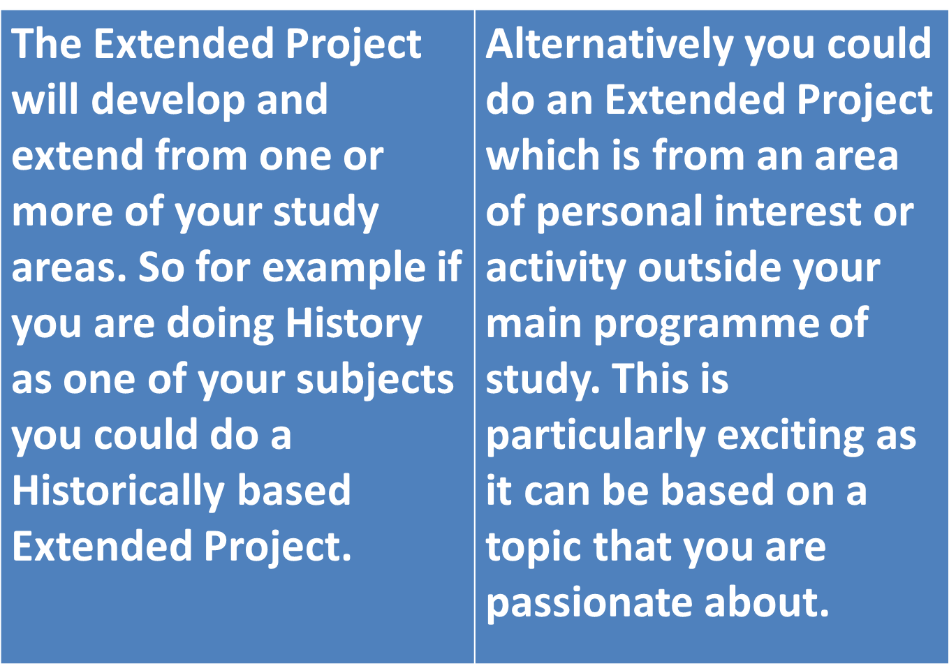

**It is your choice – you decide.**

* It will be based on a topic chosen by you.
* You will need to put together a Project Proposal in which you describe your proposed topic these then have to be agreed as appropriate by the Academy.

**The Extended Project is 100% you**

* You can structure it in virtually any way YOU want. The key is ensuring that you research your topic, provided ample evidence and finally that you can present your project to a marking panel and are able to verbally answer questions based on said presentation.
* You will need to prove that you have developed your skills by doing the project whether those be research or ICT skills for example.
* Most importantly your EPQ must be original and or innovative.
* It can be helpful to base your project on a topic that is related to what you want to study at University or the career you wish to pursue.

**What form or structure can the project take?**

It can be effective to try and make your project fit into one of the following four different structures, namely:

1. Dissertation (Traditional academic essay with a clear argument).
2. Investigation (An enquiry is made, think of the 5 Ws – who, what, when, where and were).
3. Performance (Dramatisations and performing arts).
4. Artefact (An actual object is created think of a model, machine or product).

**Some examples of Extended Projects**

* A children’s storybook which the learner actually managed to get published.
* A Viking silver necklace needle case.
* A ballet production (note this was a group work task and you will not have this option).
* **[](http://img1.wikia.nocookie.net/__cb20071109091305/psychology/images/a/a9/Example.jpg)**Zeppelins WWI.
* Is the DRC democratic?
* Implications of 3D printing on the motor spares industry.
* Cleaning up Space Junk.
* Evolution of Women's fashion in Britain since WWII.
* Media to blame for negative body image?
* Comparison between the UK and USAs constitutions.
* Music and Meaning - a study in youth subculture.
* Is the NHS sustainable?
* Is internet bullying real or just another media scare?
* A hobby.

**EPQ Learning Outcomes**

* **Identify**, design, plan and complete an individual project, applying a range of organisational skills and strategies to meet agreed objectives.
* **Obtain**, critically select and use select information from a range of sources; analyse data, apply it relevantly and demonstrate understanding of any appropriate linkages, connections and complexities of the topic.
* **Select** and use a range of skills, including new technologies where appropriate, solve problems, take decisions critically, creatively and flexibly, to achieve planned outcomes.
* **Evaluate** outcomes both in relation to agreed objectives and own learning and performance.
* **Use** a range of communication skills and media to present evidenced outcomes and conclusions in appropriate format.

**[](http://ukedchat.com/wp-content/uploads/2013/05/Learning-Objectives.gif)Aims - The EPQ offers opportunities for learners to:**

* Make a significant contribution to the choice and design of an extended project and take responsibility either for an individual task or for a defined task within a group project.
* Develop and improve their own learning and performance as critical, reflective and independent learners.
* Develop and apply decision-making and, where appropriate, problem-solving skills.
* Extend their planning, research, critical thinking, analysis, synthesis, evaluation and presentation skills.
* Where appropriate, develop confidence in applying new technologies in their studies.
* Develop and apply skills creatively, demonstrating initiative and enterprise.
* Use their learning experiences to support their aspirations for higher education and/or career development.
* Transfer skills developed as part of their extended project to other areas of study.

**The Taught Element of the EPQ**

The EPQ is roughly 120 hours’ worth of study, of which 30 hours is guided. The other 90 hours is made up of independent study.

You will however also be assigned a member of staff as a supervisor/mentor who can help guide you as and when necessary and assist with some elements of the guided part of the course depending on your project.

Work completed by the learner as directed within this taught element will not form part of the evidence for assessment. Individual exercises carried out by the learner as part of this taught element cannot contribute directly to the assessment for the EPQ although they may inform the supervisors' assessment of the learner's decision making in choice and use of newly developed skills.

**The Taught Element will include:**

* Any skills or techniques that will be required for the safe and effective execution of the project which are not part of the candidate's course of study. e.g. safe laboratory or workshop technique, professional codes of practice, ethical guidelines, research methodology.
* ICT skills that will enhance the production of the report and/or the development of the project covering research, analysis and execution.
* Research skills including the ability to search for and identify suitable sources of information and prior research or relevant work already undertaken.
* Project management skills including time, resource and task management (this will especially be the case with regards to your supervisor who will ensure you meet the requisite deadlines).
* In the case of a performance, production or artefact, the format and content of rehearsal notes, initial sketches or other working documents in the stages of production.
* The format and structure of accepted academic forms of research report to include abstract, introduction, background research, further research content with all sources cited, discussion, conclusion, references, including the evaluation of sources.
* Personal, Learning and Thinking Skills, Functional Skills and Key Skills.



**What next…**

* Prospective EPQ Students i.e. those who wish to undertake an EPQ need to submit a project proposal as part of their transition work into year 12.
* Ideally students undertaking an EPQ should aim to complete their project in year 12.
* The deadline for project will be the end of September with the presentations being conducted in front of a marking panel in early October (so as to support the UCAS submission/deadline).
* With final submission of projects to exam boards for moderation during summer term.
* Do note that the ultimate deadline for all coursework, including the EPQ is internally the 15th of April for final submission to examination boards the 15th May as per the Ofqual regulations.

See: <https://www.gov.uk/government/organisations/ofqual>

**[](http://www.irisclasson.com/wp-content/uploads/2012/09/lists.jpg)Summary**

**Learners are required, with appropriate supervision, to:**

* Choose an area of interest.
* Draft a title and aims of the project for formal approval by the centre (see Project Proposal Template in tasks below).
* Plan, research and carry out the project (This also requires the creation of a Project log).
* Provide evidence of all stages of project development and production for assessment.
* Deliver a presentation to a specified audience, i.e.: the marking panel.

**Malpractice**

Your work must be your own and not copied from the internet or other sources. If this is found out to be the case, you will not be awarded the Qualification.

**Consider yourselves warned**.

**Plagiarism Definition:** *“In an instructional setting,****plagiarism****occurs when a writer deliberately uses someone else's language, ideas, or other original (not common-knowledge) material without acknowledging its source”.* From:

[*wpacouncil.org/positions/WPAplagiarism.pdf*](http://wpacouncil.org/positions/WPAplagiarism.pdf)

**Remember:** Always be polite to your sources. Good referencing actually adds validity to your work.

 See Oxford University’s advice on plagiarism as it contains excellent examples. <https://www.ox.ac.uk/students/academic/guidance/skills/plagiarism?wssl=1>

The policy for coursework will be as follows:

* You will be informed
* Your teachers will be informed and any other subjects which contain coursework will be checked for plagiarism as well.
* Your parent/s will be informed
* The rest of the student body will be informed.
* The exam board will be informed and this will likely result in a zero being awarded for the coursework it can also potentially see the student being withdrawn from all the subjects they do for that exam board. Other exam boards will however also be notified.
* All of your prospective universities will be notified and this could result in your applications being withdrawn
* I will also notify the publisher of the work which was plagiarised and this may result in the publisher and or author taking legal action for intellectual property theft.
* Plagiarism is a serious offense – do not do it.

For example the guidelines by the AQA read as follows and other examination boards have similar.

Coursework – From <https://www.aqa.org.uk/student-and-parent-support/malpractice>

Follow this general guidance to avoid malpractice in your coursework and other non-exam assessment.

* Only submit work that is your own.
* Never lend your work to anyone. You can get in trouble if they copy you, even if you didn't know they had or intended to.
* Make sure you know how to reference other people's work. If you want to quote someone or use someone else's words, make sure you show or reference where the quote has come from, otherwise it could be seen as plagiarism. Check with your teachers which referencing or citation style you should use. The key is to be consistent.
* Type or hand-write your own work for submission. If you need help to do this, make sure you acknowledge that someone else has helped you. Speak with your exams officer for more information about access arrangements.

Speak to your teachers if you're worried about any of these points.

|  |
| --- |
| *We welcome the introduction of the Extended Project and would encourage you to undertake one as it will help you develop independent study and research skills and ease the transition from school/college to higher education.*  - University of Cambridge |

**Tasks:**

1. **Consider finding, purchasing and reading the following:**

**Official AQA textbooks include (the first option here is possibly the best):**

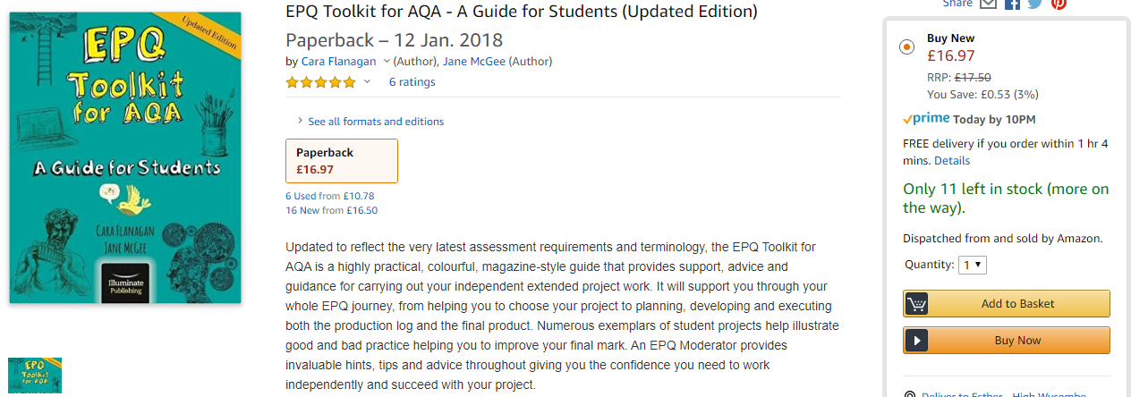

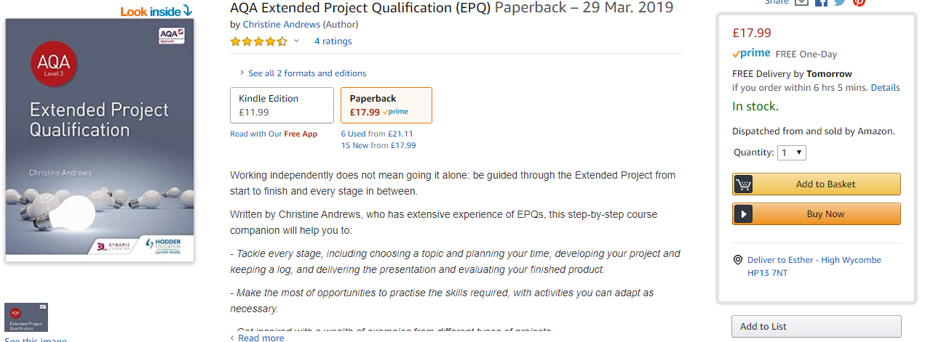

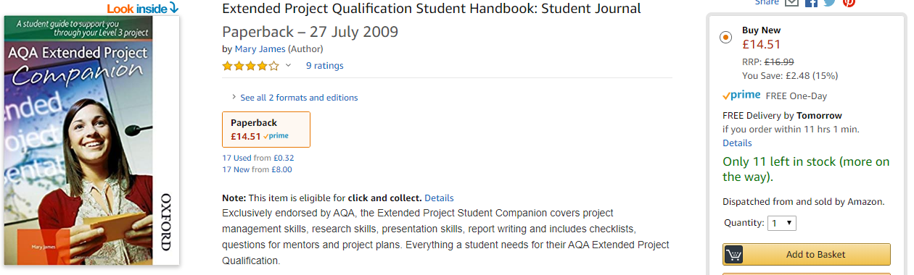

1. **Download and read the AQA EPQ Specification and quick guides:**

<https://www.aqa.org.uk/subjects/projects/project-qualifications/EPQ-7993/teaching-and-learning-resources?gclid=Cj0KCQjww_f2BRC-ARIsAP3zarFi9AsNrIkBSFd013HDJFjvsYCpaSWvS7e0G9le-vASg-qbbUK9MnkaAnIBEALw_wcB>

The Student Room has an excellent guide available here: <https://www.thestudentroom.co.uk/showthread.php?t=4846922>

1. **Read the following two sample proposals and then complete your own proposal form as part of your EPQ and transition work into Year 12.**

**EXAMPLE 1:**

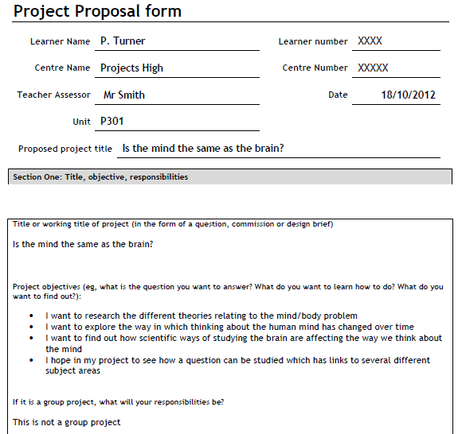

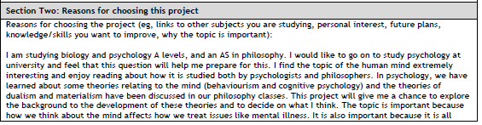

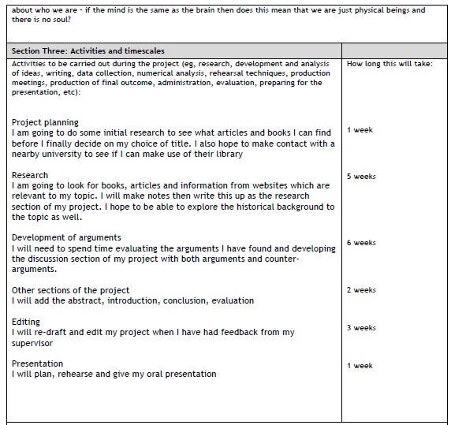

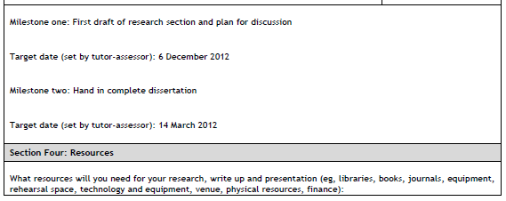

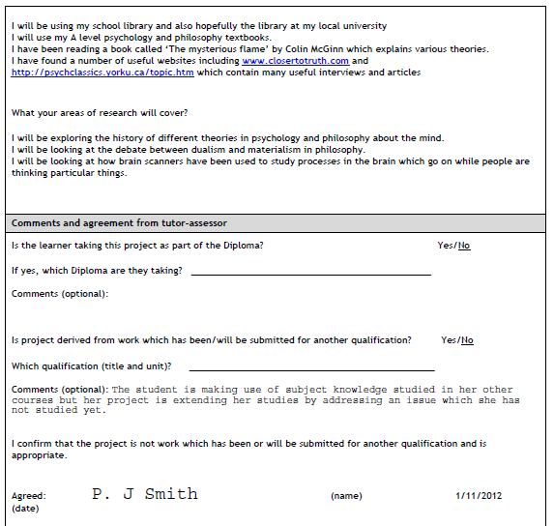

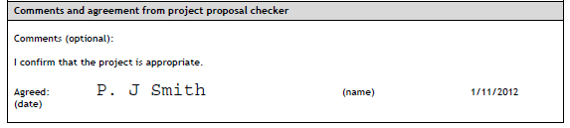

**EXAMPLE 2:**

|  |  |  |  |  |  |  |
| --- | --- | --- | --- | --- | --- | --- |
| Extended Project Proposal form | | | | | | |
| Learner Name |  | |  | Learner number |  |  |
|  |  | | |  | |  |
| Centre Name | Langley Academy | |  | Centre Number |  |  |
|  |  | | |  | |  |
| Teacher Assessor |  | |  | Date |  |  |
|  |  | | |  | |  |
| Unit |  | |  |  | |  |
|  |  | | |  | |  |
| Proposed project title | | The cat sat on the mat. An in depth analysis of feline behaviour especially in relation to a commonly found area of comfort in most homes namely the mat. | | | |  |
|  | | | | | | |
| Section One: Title, objective, responsibilities | | | | | | |

|  |  |
| --- | --- |
| Title or working title of project (in the form of a question, commission or design brief)  Title: The cat sat on the mat.  Subheading: An in depth analysis of feline behaviour especially in relation to a commonly found area of comfort in most homes namely the mat.  Key question: Do cats in actuality sit on mats. The main thrust of the argument therefore needs to establish cat behavioural patterns and in doing so consider the likelihood of a cat actually sitting on a mat. This then will also need to take into consideration what other activities cats do on mats.  Design Brief: This project will take the form of an enquiry with then observed feline behaviour observed being compiled into a written report with the final presentation being a PowerPoint accompanied by a video incorporating some of the evidence in support of the final judgement. The study will thus need to look at a sample of a cat population with access to mats so domesticated cats that live in homes that contain at least a mat. Note a distinction will need to be drawn between mats and other forms of carpeting. Likewise too the presence of other comforts (these will be referred to broadly as creature comforts - such as bedding) may affect the behaviour of the cats studied.  A sample of cats must therefore be found and their owners interviewed, especially in terms of their own observations of their cats so as to establish whether or not their cat in fact uses a mat on any sort of regular basis. The cats themselves will then need to be monitored with the use of both a tracking device for indeed the cat may be using mats elsewhere and also with video equipment checking the cats in relation to mats within the home. Etc… | |
| Section Two: Reasons for choosing this project | |
| Reasons for choosing the project (eg, links to other subjects you are studying, personal interest, future plans, knowledge/skills you want to improve, why the topic is important):  To be perfectly frank I have a cat fetish. Indeed I have always had cats and will continue to do so till my dying day. I have a keen interest in cats and especially cat behaviour. I wish to one day study and specialise in feline behaviour and become a cat specific pet psychologist. I study psychology biology and science and these subjects should provide me with the academic approach required by such a study. Given that I have been observing cats for years I already have a good general knowledge of cat behaviour. What is more is that I am an avid reader of books about cats. Most recently for example I read that book by the celebrated academic on cats BM Chinchen called “The cat that sat on the mat” which is going to be the basis in many respects of this study as I hope to provide substantiated field research and evidence for his assertions. The skills I specifically hope to learn/improve include interview techniques and field research especially also the tracking and compilation of evidence based on an observed behaviour. Etc… | |
| Section Three: Activities and timescales |  |
| Activities to be carried out during the project (eg, research, development and analysis of ideas, writing, data collection, numerical analysis, rehearsal techniques, production meetings, production of final outcome, administration, evaluation, preparing for the presentation, etc):  Research and note taking  Write up  Presentation, in the form of slide show or video documentary  Write an interview questionnaire in such a way that the data from it can easily be assessed statistically. Needs to thus be based on close ended questions which can then be tabulated mathematically in a graph. | How long this will take:  1 hour 40 minutes to create a document with another additional 2 hours editing and testing the validity and usefulness of the questionnaire with friends before using it in the field. |
| Milestone one:  Sample of cats to be studied identified.  Target date (set by tutor-assessor):  Milestone two:  Data being collected from the field study.  Target date (set by tutor-assessor): | |
| **Section Four: Resources** | |
| What resources will you need for your research, write up and presentation (eg, libraries, books, journals, equipment, rehearsal space, technology and equipment, venue, physical resources, finance):  What your areas of research will cover?  Chinchen BM, “*The cat that sat on the mat*”, Feline publishing house, 2008.  www.my kittycat.com  The cat museum in Meow.  Money for video and monitoring equipment cost and supplies from tracking cats inc. £500. | |
| **Comments and agreement from tutor-assessor** | |
| Is the learner taking this project as part of the Diploma? Yes/No  If yes, which Diploma are they taking? ______________________________________________  Comments (optional):  Is project derived from work which has been/will be submitted for another qualification? Yes/No  Which qualification (title and unit)? _____________________________________________  Comments (optional):  I confirm that the project is not work which has been or will be submitted for another qualification and is appropriate.  Agreed: (name) (date) | |
| **Comments and agreement from project proposal checker** | |
| Comments (optional):  I confirm that the project is appropriate.  Agreed: (name) (date) | |

|  |  |  |  |  |  |  |
| --- | --- | --- | --- | --- | --- | --- |
| **Project Proposal Blank Document – to be filled in as part of your EPQ Proposal.**  Extended Project Proposal form | | | | | | |
| Learner Name |  | |  | Learner number |  |  |
|  |  | | |  | |  |
| Centre Name | Langley Academy | |  | Centre Number |  |  |
|  |  | | |  | |  |
| Teacher Assessor |  | |  | Date |  |  |
|  |  | | |  | |  |
| Unit |  | |  |  | |  |
|  |  | | |  | |  |
| Proposed project title | |  | | | |  |
|  | | | | | | |
| Section One: Title, objective, responsibilities | | | | | | |

|  |  |
| --- | --- |
| Title or working title of project (in the form of a question, commission or design brief) | |
| Section Two: Reasons for choosing this project | |
| Reasons for choosing the project (eg, links to other subjects you are studying, personal interest, future plans, knowledge/skills you want to improve, why the topic is important): | |
| Section Three: Activities and timescales |  |
| Activities to be carried out during the project (eg, research, development and analysis of ideas, writing, data collection, numerical analysis, rehearsal techniques, production meetings, production of final outcome, administration, evaluation, preparing for the presentation, etc):  Research and note taking  Write up  Presentation, in the form of slide show or video documentary | How long this will take: |
| Milestone one:  Target date (set by tutor-assessor):  Milestone two:  Target date (set by tutor-assessor): | |
| **Section Four: Resources** | |
| What resources will you need for your research, write up and presentation (eg, libraries, books, journals, equipment, rehearsal space, technology and equipment, venue, physical resources, finance):  What your areas of research will cover? | |
| **Comments and agreement from tutor-assessor** | |
| Is the learner taking this project as part of the Diploma? Yes/No  If yes, which Diploma are they taking? ______________________________________________  Comments (optional):  Is project derived from work which has been/will be submitted for another qualification? Yes/No  Which qualification (title and unit)? _____________________________________________  Comments (optional):  I confirm that the project is not work which has been or will be submitted for another qualification and is appropriate.  Agreed: (name) (date) | |
| **Comments and agreement from project proposal checker** | |
| Comments (optional):  I confirm that the project is appropriate.  Agreed: (name) (date) | |

1. **Please complete the following document of commitment.**

If you are interested in doing the EPQ, fully realising the expectations and responsibilities that are required by this qualification.

Can you please sign the Document of Commitment and formally confirm that you want to be involved in this project.

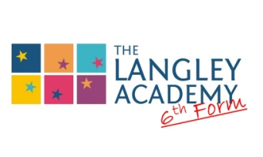**Document of Commitment**

**The AQA Extended Project Qualification (EPQ)**

I ________________________________ (full name and surname) hereby confirm my commitment to attempting to complete the AQA Extended Project Qualification.

I have been made fully aware of the expectations and commitments expected by this qualification and that the project may require as much as 120 hours of my time, possibly more.

I hereby undertake to attempt to meet the various deadlines and complete the project to the best of my ability. I am therefore fully committed to attempting this qualification.

I understand that the project entails the following broad criteria and that each has its own requisite tasks, namely:

* Choose an area of interest.
* Draft a title and aims of the project for formal approval by the centre.
* Plan, research and carry out the project.
* Provide evidence of all stages of project development and production for assessment.
* Deliver a presentation to a specified audience, i.e.: the marking panel.

I also hereby confirm that the project will be my own work and that I understand the consequences of plagiarism. I will therefore ensure academic professionalism especially when it comes to conducting research. I will also ensure that I look after the Extended Project Activity Pack; received today at the EPQ Induction and that I will return it to the academy at the end of the course.

Yours sincerely

_____________________________ (Signature) Date: _______________

